Healthcare Appointment Cancellation Analytics
Operational Insights and Predictive Modeling
Executive Report
Prepared By:
Jose Reyes
MS Business Analytics & Artificial Intelligence
University of Texas Rio Grande Valley
May 2026

Executive Summary
Healthcare appointment cancellations negatively impact provider utilization, staffing efficiency, scheduling operations, and revenue generation. This project analyzed healthcare appointment scheduling data to identify operational factors associated with appointment cancellations and evaluate predictive machine learning models capable of identifying high-risk appointments.
The analysis identified several operational patterns associated with increased cancellation risk. Longer scheduling lead times, prior cancellation history, and older patient age groups emerged as important predictors of cancellations. Patients aged 60 and older demonstrated elevated cancellation rates compared to younger age groups. Additional operational factors such as address verification and technical assessment completion also showed relationships with appointment retention.
Three machine learning models were evaluated: Logistic Regression, Balanced Logistic Regression, and Random Forest. Among these approaches, the Random Forest model achieved the strongest overall predictive performance balance and provided insight into the most influential operational drivers.
The findings support several operational recommendations, including reducing scheduling lead times, strengthening patient verification workflows, prioritizing proactive outreach for higher-risk patients, and improving patient engagement during appointment preparation workflows.

Business Problem
Healthcare appointment cancellations create operational inefficiencies that negatively affect scheduling effectiveness, staffing allocation, provider utilization, and revenue generation.
The goal of this project was to:
• Identify factors associated with appointment cancellations
• Evaluate predictive machine learning models
• Generate actionable operational recommendations

Dataset Overview
The dataset included appointment scheduling information, patient demographics, workflow completion indicators, representative assignments, and historical cancellation behavior.
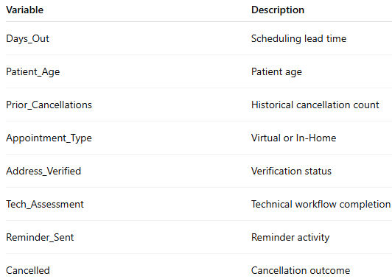

Exploratory Data Analysis

Overall Cancellation Rate
The dataset demonstrated a high cancellation rate of approximately 58.7%, indicating a significant operational challenge and establishing the need for predictive intervention strategies.
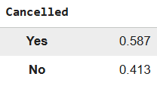
Figure 1: Overall cancellation distribution shows that approximately 58.7% of appointments were cancelled.

Cancellation by Appointment Type
Cancellation behavior was compared across appointment types. In-Home appointments demonstrated slightly higher cancellation counts compared to Virtual appointments.
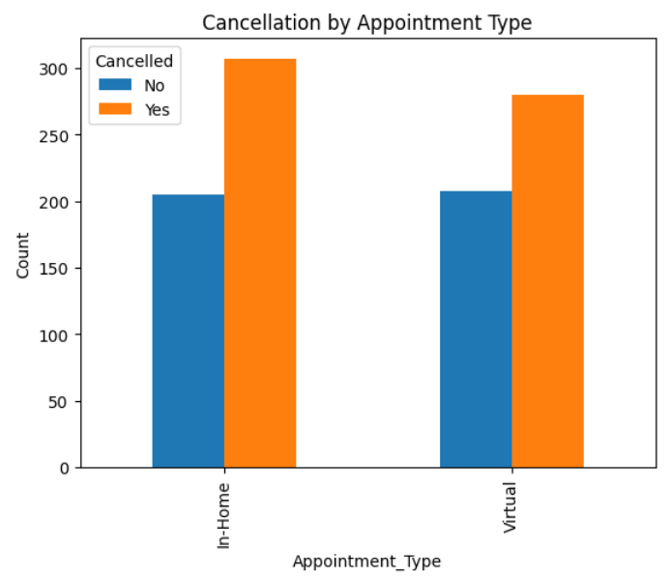
Figure 2: Cancellation counts by appointment type.

Operational Findings
Appointments scheduled further into the future demonstrated slightly higher cancellation rates. Longer scheduling windows may increase cancellation risk due to reduced patient engagement and increased scheduling conflicts.
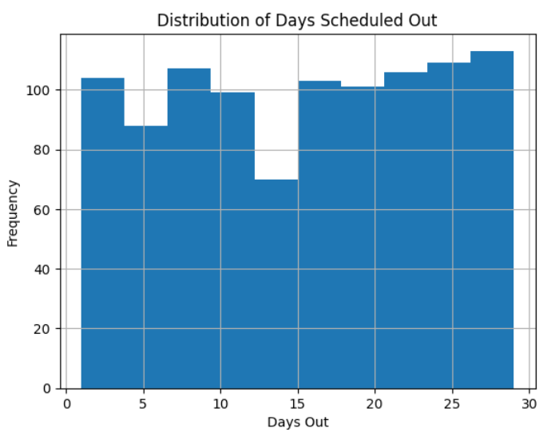
Figure 3: Distribution of scheduling lead times across appointments.

Address Verification and Technical Assessment
Appointments with verified addresses and completed technical assessments demonstrated lower cancellation rates compared to incomplete workflows.
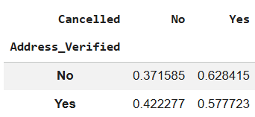
Figure 4: Address verification analysis showing lower cancellation rates among verified appointments.
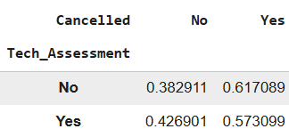
Figure 5: Technical assessment analysis showing improved appointment retention among completed assessments.

Machine Learning Modeling
Three machine learning models were evaluated:
• Logistic Regression
• Balanced Logistic Regression
• Random Forest
A stratified train/test split was implemented to preserve cancellation class balance across training and testing datasets. Model evaluation focused on accuracy, recall, precision, and overall predictive balance.
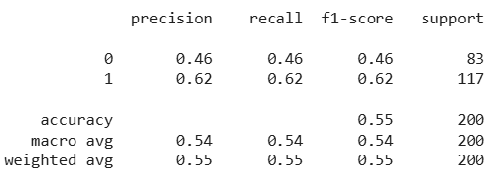
Figure 6: Balanced Logistic Regression classification report.

Random Forest Model
The Random Forest model achieved the strongest overall predictive performance balance and captured nonlinear relationships between operational variables.
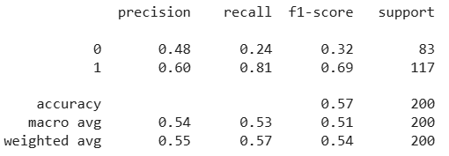
Figure 7: Random Forest classification report.

Feature Importance Analysis
Feature importance analysis identified Patient Age, Days Scheduled Out, Prior Cancellations, and Technical Assessment completion as the strongest operational drivers of cancellation prediction.
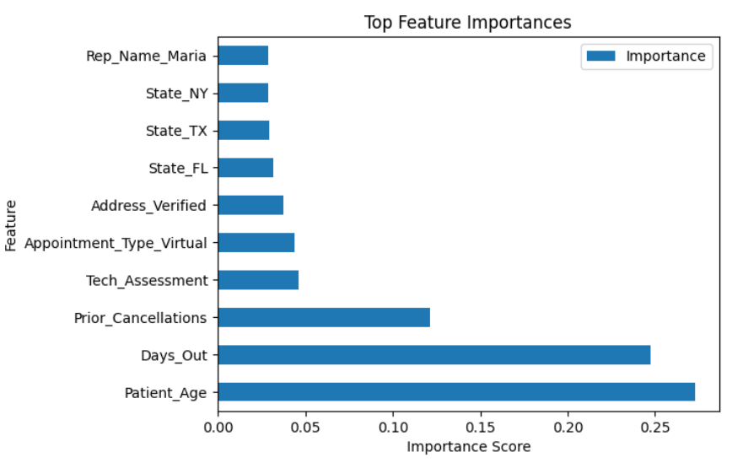
Figure 8: Random Forest feature importance analysis.

Patient Age Segmentation
Although average age differences appear modest overall, segmented analysis revealed elevated cancellation rates among patients aged 60 and older.
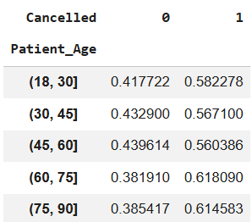
Figure 9: Patient age segmentation analysis demonstrates elevated cancellation rates among patients aged 60 and older.

Conclusions and Recommendations
The analysis identified several operational variables associated with appointment cancellations. Longer scheduling lead times, prior cancellation history, and older patient age groups emerged as important predictive factors. Technical assessment completion and address verification workflows were associated with improved appointment retention outcomes.
Among the evaluated machine learning approaches, the Random Forest model provided the strongest overall predictive balance and successfully identified important operational drivers of cancellation behavior.
Recommendations:
1. Reduce scheduling lead times where operationally feasible
2. Prioritize proactive outreach for patients aged 60 and older
3. Strengthen address verification workflows
4. Flag patients with prior cancellation history for proactive follow-up
5. Improve patient engagement during technical assessment workflows
6. Continue monitoring representative-level operational trends

Expected Operational Impact
Implementation of the recommended operational strategies may help reduce cancellation rates, improve provider utilization, increase staffing efficiency, and support more proactive scheduling workflows.

Limitations and Future Enhancements
Several limitations should be considered, including the synthetic nature of the dataset and the inherent difficulty of predicting human cancellation behavior.
Future enhancements may include Power BI dashboard deployment, SQL integration, XGBoost implementation, and real-time cancellation risk scoring systems.

